JMR-17-1155-0 Response to Reviewers

**Comments from Reviewer 1**

1. “The demonstrated deflection seems to violate the small angle assumptions. Although the FEA is thorough, the data in Figure 15 shows that the approximate model is more accurate than FEA even though the model is based on small angle assumptions. It seems that the FEA should have been more accurate, and generally within 2% of the actual displacement predictions.”

The accuracy of the FEA simulations are affected by limitations in defining the loading conditions for the model. Namely, for the kinematics model in Fig. 15, the “cable displacement” for the FEA model includes a rigid body motion and a stretching component. The stretching component artificially increases the perceived cable displacement in the FEA model making the curve more “flat”. For the FEA simulations, the displacement of the cable base was directly measured because it most closely follows the procedure used in the physical validation experiments. However, the properties of the simulated cable body and the actual physical actuation cable vary. This difference was necessary in order to achieve convergence of a solution. The actual cable is braided and the model was assumed to be a single cylinder to simplify the model. The diameter of the cylinder was also slightly larger than the diameter of the cable in order to increase the contact area and mesh density between the simulated cable and the tube. Using cables with smaller diameter in some cases resulted in the cable’s mesh penetrating into the tube. The configuration presented in the paper represents the best combination of simulation parameters that we achieved.

An alternative approach that we have used to extract data from the FEA simulation is to directly measure the “closing” distances of the notches. This approach uses the exact came FEA simulation results as before but infers the cable displacement indirectly. The benefit of this approach is that it is insensitive to the simulated cable’s stretching, however, it does not use the same approach as the physical experiments to collect the displacement data. The original Fig.15-o where the displacement of the cable’s tip was measured is compared to an updated Fig. 15-u where the closing distances of the notches are measured which indirectly represent cable displacement. These ANSYS results are from the same model.

A screenshot of a cell phone

Description generated with very high confidence

**Original Fig. 15 -o Updated Fig. 15-u**

1. “The given analytical model seems incomplete as a number of design considerations were not accounted for or not considered. Pseudo-Rigid Body Modeling with nonlinear beams or a 2D modeled beam with an end load and a moment with additional contact(s) occurring after initial deflection might be worth considering.”

The PRBM approach was initially considered during the development of this project, but was not pursued for the following reasons. The PRBM substitutes the compliant joint for one or more rigid bodies connected by a spring. Therefore, the designer must determine a defensiblecharacteristic stiffness for the spring and also a characteristic length for the rigid bodies. The contact-aided joint presented in this paper poses the following challenges. First, the nonlinear behavior of the characteristic stiffness, caused by the phase-transformation of nitinol, is not clearly linked to bending or displacement, but instead to strain and the overall shape of the neutral axis of compliant joint. Aside from the nonlinear effect on stiffness caused by the contact-aid, it was not clear to the authors how to implement the nonlinear behavior of the nitinol material itself without considering the strain in the material. This effect is significant because of the large deflections the that joint undergoes and the large strains 4-6% that it experiences. Approximating a linear “Young’s modulus” for the nitinol in these conditions seems to be a significant source of inaccuracy. This problem was addressed in the cited papers in Reference [1] and Reference [2], which use a kinematic approximation to determine the tip location of a rectangularly cut compliant notch joint, and then using this condition, solve for an accurate shape of the neutral axis of the joint, infer the strain profile and compute the nonlinear stiffness from this information. The model we use in this paper follows the same strategy.

We believe that the PRBM model could reasonably describe the contact-aid behavior and motion of the joint, but do not yet have a strategy to model the nonlinear material properties of nitinol that is compatible with the PRBM approach. One possibility that we considered was fitting an approximate non-linear stiffness to the characteristic spring, but we felt that this semi-empirical approach was less generalizable and less useful for predicting joint behavior because it required experimental data for input.

Not sure how else to addresses this – seems like more of a suggestion

* We will add a section into the discussion to highlight potential future directions for modelling.
* This model achieves a level of accuracy that is sufficient for our purposes
* Is model refinement and improvement necessary for the scope of a “Design Innovation” paper?
* For the 2D approach -> we have considered modelling as a series of Cosserat rods, but have completed the analysis because the present model is sufficient.

**Comments from Reviewer 2**

1. “Fig. 14(b) fails to show an inflection in tip deflection versus applied force that would be expected with contact during experiment, as is shown in Fig. 14(a).”

To address this concern Fig. 14(b) has been updated with the plot shown below. The original Fig. 14(b), now referred to as Fig. 14 (b-o), included data collected from the specimen shown at the bottom of the plot. This earlier prototype experienced some minor plastic deformation as a result of the laser cutting. This plastic deformation resulted in the contact-aid being engaged “at rest” or in the unloaded configuration. As a result, the benefit of the contact-aid increasing stiffness can be observed in the experimental results, but the “inflection” point was not observable because the contact-aid was already “closed”.

The updated Fig. 14(b), referred to as Fig. 14 (b-u), includes data collected from a specimen cut using lower power such that the plastic deformation was significantly reduced/eliminated. Therefore, in this specimen, the contact-aid is “open” or not engaged in the unloaded configuration. As a result, both the benefit of the contact-aid increasing stiffness can be observed, and the “inflection” point where the contact-aid is engaged.

Comparing the specimen shown at the bottoms of Fig. 14(b-o) and Fig. 14(b-u), Fig. 14(b-o) is slightly curved, indicating its plastic deformation, where as Fig. 14(b-u) is much straighter. In the initial submission of this manuscript, Fig. 14(b-o) was included and not updated in error. The experimental results in Fig. 15 and 16 include data from so called “second generation” specimen like those shown in Fig. 14(b-u) where the plastic deformation issue was corrected.

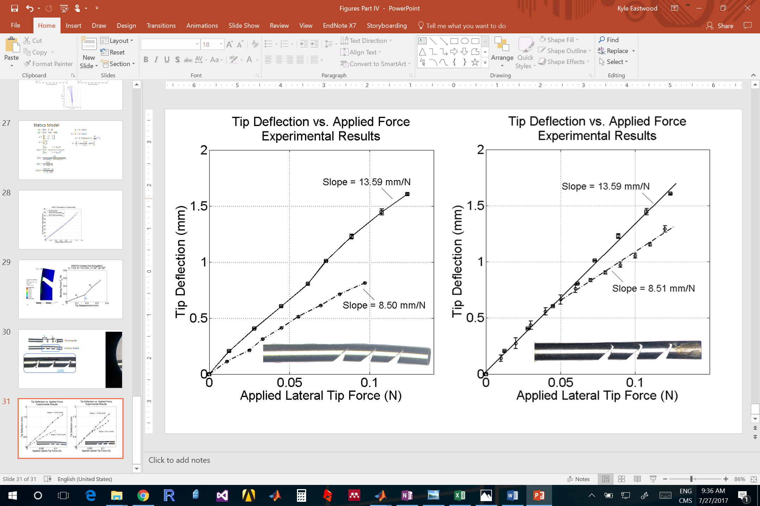

**Original Fig. 14 (b-o) Updated Fig. 14 (b-u)**

2.) “From an organization standpoint, to this reviewer at least it seems like it would be more conventional to introduce the kinematics model first, then the analytical static force model, and then continue to validation/sensitivity analysis via Ansys and finally experiments.”

We have considered organizing the paper as reviewer 2 has proposed. However, we believe that the present organization still is preferable for the following reasons: First, the emphasis of the manuscript focuses on the notch design innovation, and particularly, explaining clearly the form, function and benefits of the design as succinctly and early within the paper as possible. This focus leads naturally into why the joint is shaped the way that it is, and in particular, the relative impact of different features of the design topology. The FEA analysis communicates the utility and function of the notch topology very well. We are concerned that moving the kinematics/statics modelling before the sensitivity study may interrupt this flow. Further, since the kinematics/statics models are based on a simplified geometrical approach, the FEA sensitivity analysis informs the selection of the geometry variables used in the kinematics/statics models. Understanding the results of the FEA sensitivity study primes the reader to appreciate the choice of variables and assumptions used in the kinematics and statics models. As well, at this point, the kinematics and statics models were not used to design the joint or to conduct the sensitivity study. Placing these sections after the FEA analysis ensures that this point is not confused by the reader, and it also follows the process that we used to develop the mechanism.

With these points considered, if reviewer 2 still feels that the manuscript could benefit from reorganization, we are happy to change the structure such that the kinematics/statics models are presented before the sensitivity analysis using FEA.

3.) “I also certainly found it jarring to have quantitative results presented in Fig. 4 prior to any of the analytical methods - I think Fig. 3 or an extension of it gets the point across sufficiently that those could be left for later.”

We have chosen to present some illustrative quantitative results in Fig. 4 because our experience in presenting this data (internally) in the past has led to some confusion, and we have found that the schematic in Fig. 3 alone is not always sufficient in explaining the benefits of the contact-aid. We are also following a precedent set by *Tummala et al.* (Reference [24]) where they display an example stiffness curve for a contact-aided compliant wing in the beginning description of their paper to further illustrate the design benefits.

4.) “It is very common for figure labels and variables to not be consistently typeset across figures/equations/text. For example, numbering of designs in Fig. 1 and variable definitions after 17.”

This has been addressed throughout the paper. The sizes the of the figures have been finalized and the text-size and font used for annotations have also been standardized.

5.) “[T]he direction of force F in (6) is not well defined. The statement that it represents cable tension would seem to indicate a direction that is not necessarily parallel to the bending portion, as the cable "tilts" where it exits the next segment as in Fig. 10, so then either the force direction or the moment arm would not be exactly constant as stated after (6).”

The direction of the force F in (6) is aligned such that it is parallel with the centerline of the tube. It has also been updated to FT to distinguish it, the tendon tension force, from an externally applied blocking force FB which is used to describe the joint being used to manipulate tissue. This clarification has been added in __. This aspect of the modelling is not described in as much detail as the later sections of the model because it is based on the approach presented in Reference [1] and Reference [2] which is described in detail in these papers.

6.) Zeta from (16) would also benefit from being labeled on a graph, and may be related to my confusion about force direction. Nu is also not defined after (16), and its part of (16) could simply be omitted.”

We were unable to find the exact corrections that the reviewer is referring to. The variable Zeta (ζ) does not appear in (16), but the variable Xi (ξ) does appear in (18). This variable is labelled in Fig. 10 and explained on line 312. The variable Nu (ν) also does not appear in (16) but the variable Eta (η) does appear in (18). Eta has been omitted as recommended as it is only used once and can be substituted for by other variables.